Risk Assessment Report of Microsoft Company
Name
Institution Affiliation

Risk Assessment Report of Microsoft Company
The Microsoft Company has provided people and business with infrastructures that have enabled easier ways to operate and handle businesses daily. The way to operate a business and communications have become centralized that people can use technology to provide them with the information needed anywhere. But all this infrastructure need proper security that will ensure everyone that uses these infrastructures is secured and safe. The Microsoft Company conducted a risk assessment to determine the methodologies that can be used to ensure the security of the infrastructures that are used in daily businesses. The scope of the assessment was clearly limited to the security methodologies to the infrastructure system. This report provides the general methodologies that can be used to improve the security and effectiveness of the systems. This is to ensure that the systems are safe and properly functional. However, for an effective risk assessment, a company needs to evaluate different methodologies to effectively manage the risk that may be experienced. This report discusses some of the risk assessment methodologies and selects one methodology that can be used in the security infrastructure of Microsoft.
The Risk Assessment Methodologies
The security of the infrastructures of any business needs to have an effective method to maintain and manage the security. There are several types of risk assessment methodologies that can be used. Below are some of the risks assessment methodologies that can apply to ensure the security of the infrastructure of Microsoft.
- The Information Security Forum (ISF) IRAM 2
This is a risk methodology that gives the organization the opportunity to assess its information risks. Through this method (IRAM 2), an organization is able to formulate a comprehensive understanding of its information risk and come up with management strategies that ensure the safety of the information (Agwaral, 2017). Specifically for organization IRAM 2 works in a unique way in different phases. The methodology has the capacity to assess the risk components like the vulnerability, impact, and threats. With the IRAM 2, any organization is able to come up with a common language that will enable the organization to have a common view of information risk. This, in turn, assists the businesses or organization to manage and maintain the security if their information. Moreover, this risk assessment methodology gives risk analysts the opportunity to assess the information risk in the line of the organization perspective.
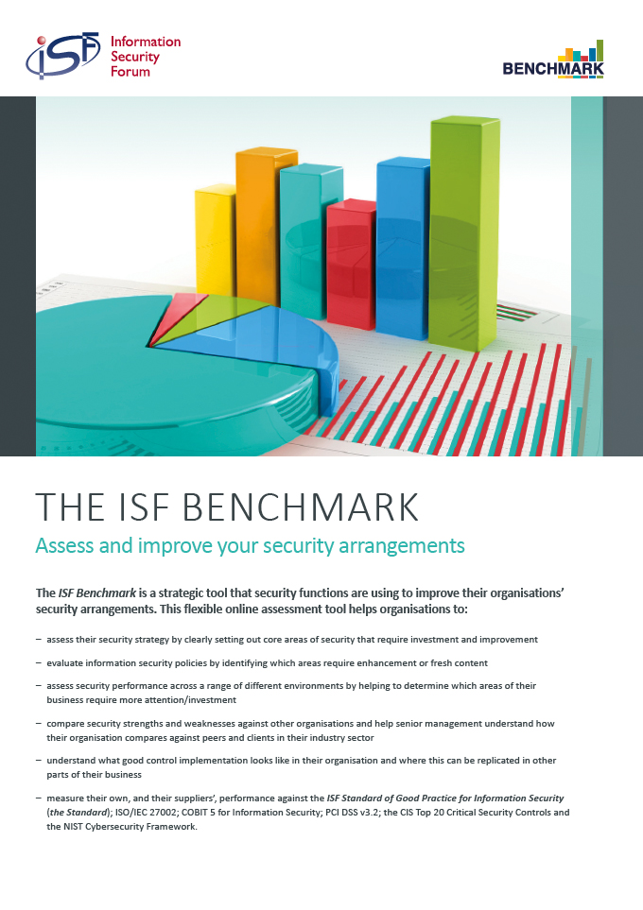
ii). CESG Information Assurance Standard 1 &2
This risk assessment methodology provides a framework that gives the space for defining the possibility of the assessment and the conforming information assets after which it holds the assessment of the vulnerability, impact, and threat. This methodology clearly gives the way that an organization can use to come up with plans that can be used to treat the risk, develop an assurance plan and outline an approach to be implemented to the identified controls, but strongly based on the ISO/IEC 27002:2013. The methodology also gives the organization an opportunity to conduct an outstanding assessment and analyze gaps in the risks. However, this kind of methodology is majorly used by the government and public sectors although other organizations can still apply it and use. The CESG Information Assessment Standard method is no more to use and its tools. Moreover, it is very complex and will need a highly skilled and trained analyst to conduct it. 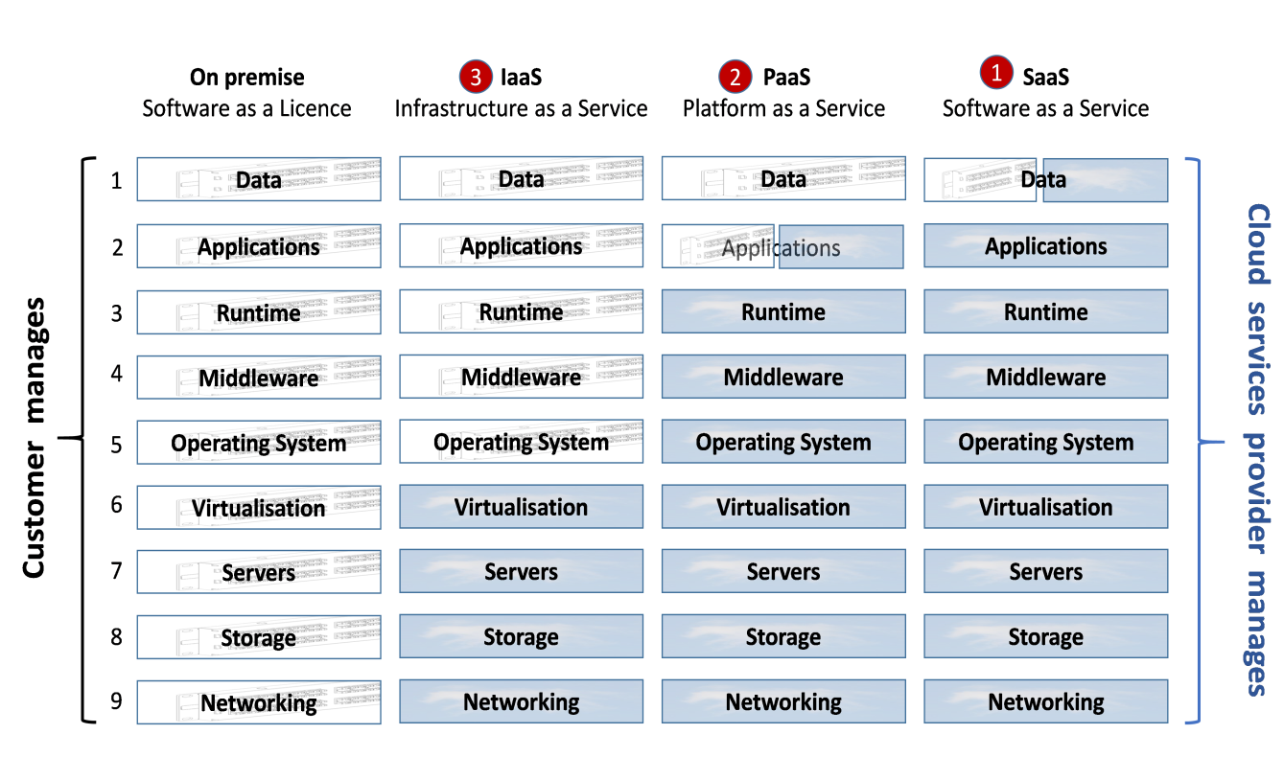
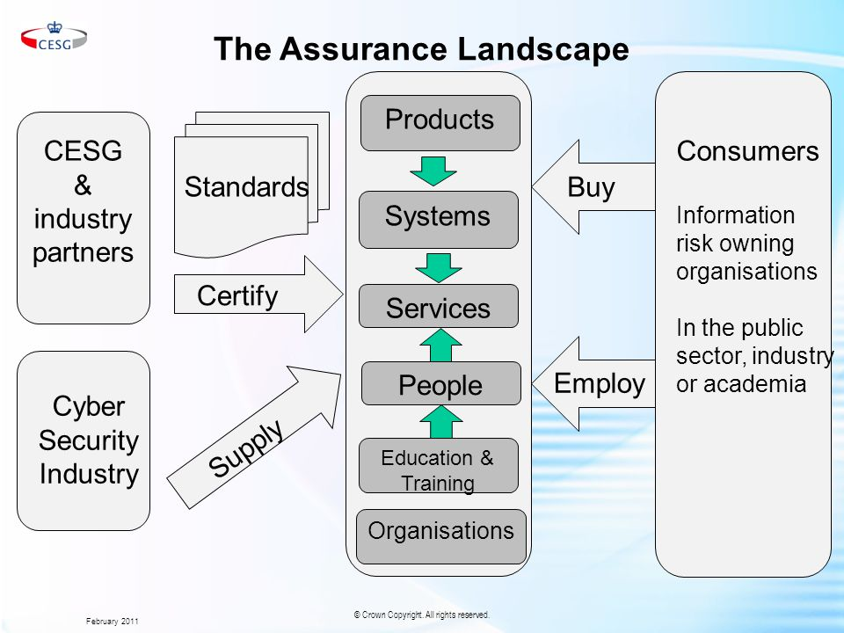
iii). ISO/IEC 27005:2011
ISO/IEC 27005 is one of the risk assessment methodologies that provide a generic process of risk assessment. It is in the family of the ISO 27000 that has a strong dependency on the other. It is a methodology that works with the security techniques and information security management requirements under the ISO/IEC 27001: 2013. According to Wangen, Hallstensen and Snekkenes (2016), this methodology provides any organization with the guidelines that can be used to assess the information security. Through this, the organization is able to manage their security of the information. The guidance of ISO 270005 is based on the quantitative and qualitative approach. Like other methodologies, ISO 27005 is also based on the assessment of vulnerability, impact, and threat. These processes must be screened then evaluated through the risk evaluation process. This will provide the organization with comprehensive decisions to handle the treatment of the risk. The methodology of ISO 27005 is very inclusive since it can be applied and used by many organizations. However, it needs skilled analysts and adequate resources to complete and implement the needs of the organization. Like other methodologies, ISO 27005 is used to give guidance on the information security system risks.
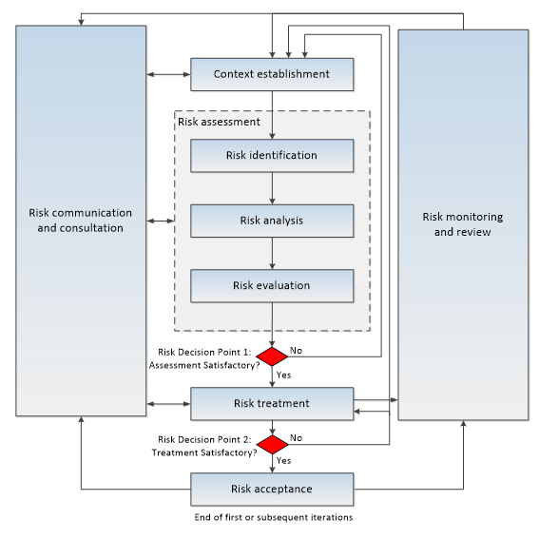
iv). Octave Allegro
OCTAVE Allegro is the recent version of the OCTAVE methodology which originated from the Carnegie Mellon University in the USA. This methodology is aimed to be used to manage the workshops and is done in small groups comprising of participants. It does not need much of expertise. OCTAVE Allegro basically comprise of qualitative assessment (Agwaral, 2017). It mainly focused on the assessment of assets using various steps. In the steps, the workshop groups can establish the consistency of the risk, measure the risk through the qualitative approach in accordance with the objectives of the organization. The risks are then measured in the real world to describe the risk. This step is then followed with the prioritizing the risks as mentioned in the risk measurement conditions then come up with a lasting solution to the risk.
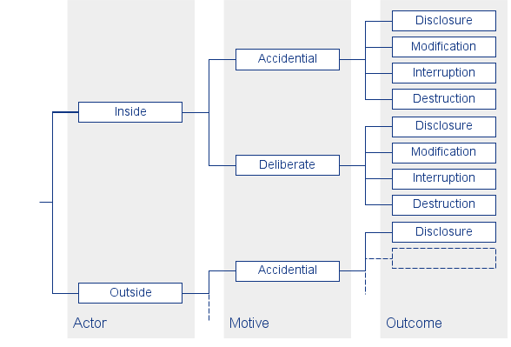
From all the mentioned methodologies in this report, IRAM 2 provides a comprehensive approach that is better for the risk assessment in the Microsoft Company. The information that company has, needs a lot of security. With the infrastructures that the company also provides to its customers are very vital. This means that a clear methodology is required to assess effectively the risks at hand. The customers trust the Company to deal and secure their information safe from being accessed. Thus, IRAM 2 becomes the best methodology that can completely assess the information security risk. This is because the methodology is comprehensive, simple and direct that analysts can understand during their work. It is updated and new and provides a clear understanding of the approach to be implemented to conduct an end to end assessment of the information security risks (Wangen, Hallstenses & Snekkenes, 2016). It is also one methodology that has fundamental techniques that when applied provides a vivid understanding of the assessment. According to Agwaral (2017), like any other organization needs coordination to effectively operate, the fundamental techniques of IRAM 2 are inclusive and engage its analysts during work. Information is critical to any organization’s performance and during the assessment; a methodology is required to perform to the best. This is what the IRAM 2 offers because it offers to focus greatly on the risks that are significant to the organization. In the assessment, IRAM 2 has enabled the process to come up with informed decisions about the ways to mitigate the problems that have been realized in the assessment. The methodology has created a significant process since it based on the concept of Microsoft under its technique of focusing on the organization perspective. Moreover, IRAM 2 is based on the broader coverage of the risk of information security. This has enabled the assessment to have broad and deep coverage of the risk obtained.

References
Agrawal, V. (2017). A Comparative Study on Information Security Risk Analysis Methods. JCP, 12(1), 57-67. Retrieved from https://pdfs.semanticscholar.org/89ad/d55bb574e1a3f1fb2e36ba8d4ba67b0ad6c4.pdf
Wangen, G., Hallstensen, C., & Snekkenes, E. (2016). A framework for estimating information security risk assessment method completeness. International Journal of Information Security, 1-19. Retrieved from https://link.springer.com/article/10.1007/s10207-017-0382-0
https://www.google.com/search?q=images+of+Octave+Allegro&client=firefox-b-ab&tbm=isch&source=iu&ictx=1&fir=TVpYliBvlwCjoM%253A%252CV8HmT3fPqbVu9M%252C_&usg=__wNZlSK33WUGNmdPc5y2ofAwMUv8%3D&sa=X&ved=2ahUKEwj6-MOHyq3aAhVKPRQKHd3RCFYQ9QEwCnoECAAQPg#imgrc=TVpYliBvlwCjoM:
https://www.google.com/search?q=images+of+ISO/IEC+27005:2011&client=firefox-b-ab&tbm=isch&tbo=u&source=univ&sa=X&ved=2ahUKEwiSp8S6yq3aAhVJ1hQKHc8yAjQQsAR6BAgAECc&biw=1366&bih=654#imgrc=z3DC49m2vNlp_M:
https://www.google.com/search?q=images+of+CESG+Information+Assurance+Standard+1+%262&client=firefox-b-ab&tbm=isch&tbo=u&source=univ&sa=X&ved=2ahUKEwiOycPlyq3aAhUMuxQKHWaIDtcQsAR6BAgAECk&biw=1366&bih=654#imgrc=P028ibEDPicN4M:

